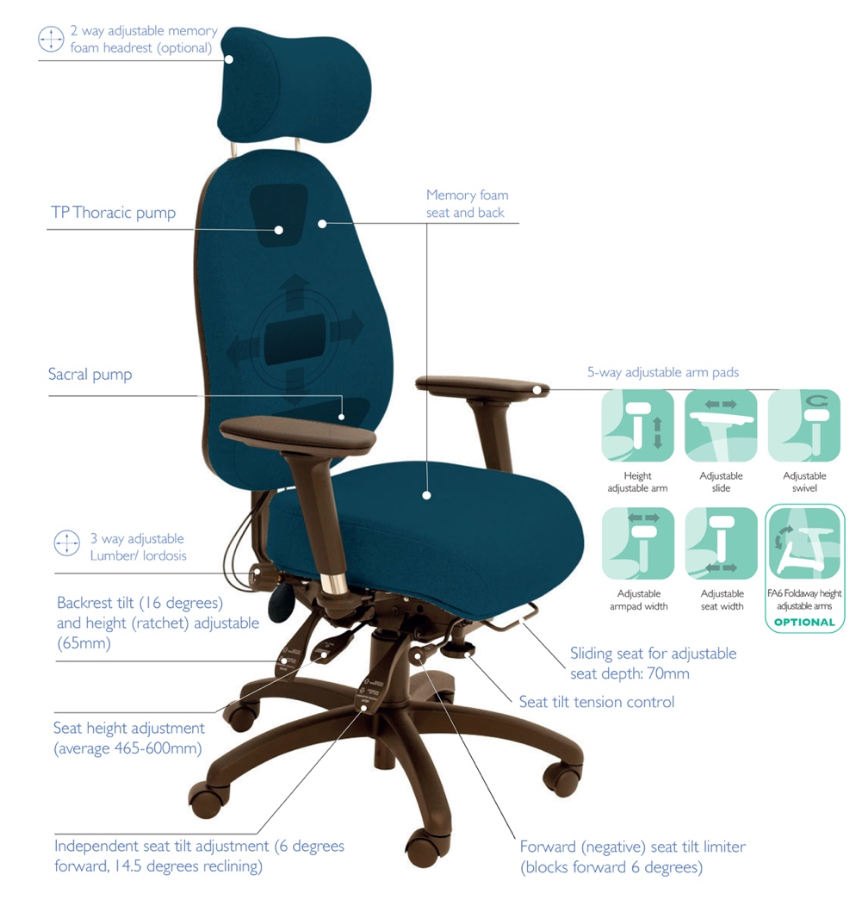
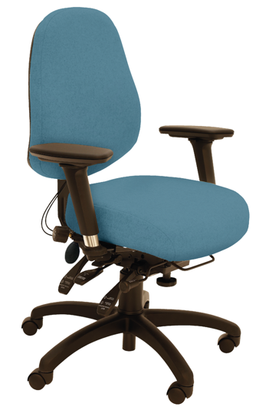
The Spynamics SD7 medium back and SD8 higher back models carry the endorsement of Occupational Health Practitioners. Working with this sector of the market, we were commissioned to make a chair that did not stand out too much from the crowd, that provided an extensive level of adjustment and comfort at as keen a price as possible. Pelvic (sacral) support is not the key here, but includes a sacral pump all the same. The usual assembly of 3-way lumbar and thoracic (shoulder height) pumps are also included. The infinite adjustable, hard wearing seat and back tilt mechanism caters for the widest population in the office as possible. Added to this, the memory foam seat and back ensures the most cost effective, customizable, therapeutic office chair on the market. Other features and benefits of these models are as follows:
SD7 SD8
Occupational Health Back Care chairs
SD8
SD7
SD8 with Headrest
For more information and prices, please contact Phil Pask on 07803 120155
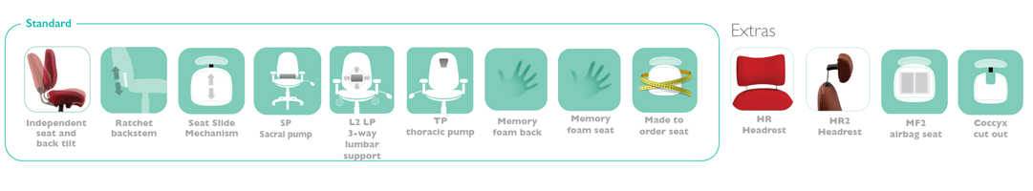

Other ergonomic features include:

- Medium or High back models with sacral pump, 3-way adjustable pump lumbar and pump lumbar
- The 6-way adjustable SPYNAMICS mechanism provides forward tilting seat with independent back rake control, seat depth, and adjustable weight control and ratchet backrest height adjustment
- Memory foam seat and back
- 5-way adjustable arms: one for height, one for forward and back, one for locking swivel and 2 width; other multifunctional and foldaway armrests are also available
- Other seat sizes are available as well as the made to order seat size

